**Mizoram**

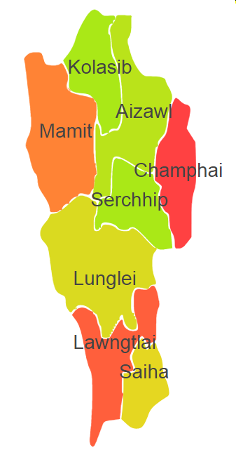

Mizoram comprises of one Agro Ecological Region (AER) 17.

**Agro-Eco Region 17:** AER 17 in Mizoram comprises of Aizawal, Champhai, Kolasib, Lawngtali, Lunglei, Mamit, Saiha and Serchhip districts of North-eastern Hills under Agro Ecological Sub Region (AESR) 17.2.

**AESR 17.2 :** The region is warm to hot perhumid ESR with medium to deep loamy Red and Yellow soils, low to medium AWC and LGP 300 days in a year.